RDS DOCUMENTATION

Utilization (On-Demand only)

Utilization, in the context of cloud computing and resources, refers to the extent to which a particular resource is being used or consumed. When discussing "On-Demand only" utilization, it typically relates to how cloud resources are used in a pay-as-you-go model, where users only pay for the resources they consume and use, without any upfront commitments or long-term contracts.
"Utilization (On-Demand only)" refers to how cloud resources are being actively used in a pay-as-you-go model, where users can request and release resources as needed and are billed based on their actual usage.

A "Custom Provided License" typically refers to a licensing arrangement where the end-user or organization provides their own software license to use a particular product or service, instead of obtaining the license directly from the software vendor or service provider. This concept can apply to various types of software, applications, or services that require licensing for legal and authorized use.

"Enterprise Database Edition" typically refers to a high-tier version of a database management system (DBMS) that is designed to cater to the needs of large organizations or enterprises with complex and demanding data management requirements. This edition often includes advanced features, scalability, performance optimizations, and enhanced security measures compared to lower-tier editions of the same database system. Different database vendors might have their own naming conventions for their enterprise editions.

Storage
Amazon RDS Custom provides you the ability to select from 20 GiB to 64 TiB of associated General Purpose (SSD) storage capacity for your primary data set. With General Purpose (SSD), you will be charged for storage you provision. However, you will not be charged for the I/Os you consume. Amazon RDS Custom provides you the ability to provision the I/O capacity your database needs. You can provision and scale from 1,000 IOPS to 80,000 IOPS and 20 GiB to 64 TiB of storage.

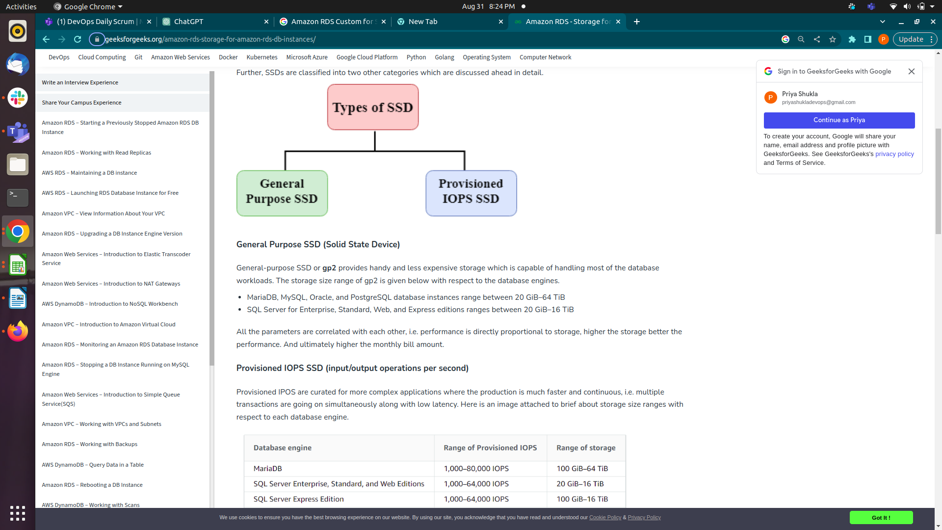

General Purpose SSD (Solid State Device)
General-purpose SSD or gp2 provides handy and less expensive storage which is capable of handling most of the database workloads. The storage size range of gp2 is given below with respect to the database engines.

- MariaDB, MySQL, Oracle, and PostgreSQL database instances range between 20 GiB–64 TiB
- SQL Server for Enterprise, Standard, Web, and Express editions ranges between 20 GiB–16 TiB
All the parameters are correlated with each other, i.e. performance is directly proportional to storage, higher the storage better the performance. And ultimately higher the monthly bill amount.

Provisioned IOPS SSD (input/output operations per second)
Provisioned IPOS are curated for more complex applications where the production is much faster and continuous, i.e. multiple transactions are going on simultaneously along with low latency. Here is an image attached to brief about storage size ranges with respect to each database engine.

Backup Storage
Backup storage for Amazon RDS Custom is the storage associated with your automated database backups and any customer-initiated DB snapshots. There is no additional charge for backup storage of up to 100% of your total database storage in in the destination region.

Pricing model

The pricing models "On-Demand" and "Reserved" are commonly used in cloud computing, particularly for services like virtual machines, databases, and other resources provided by cloud service providers. These models determine how you pay for and utilize these resources.
In the On-Demand pricing model, you pay for cloud resources (such as virtual machines, storage, or databases) based on the actual usage. It's a pay-as-you-go model where you're charged for the resources you consume over time, typically on an hourly or per-minute basis. This model offers flexibility, as you can provision resources quickly and release them when they're no longer needed. However, the cost per unit of time is generally higher compared to other models.

Benefits:

- Flexibility to provision resources instantly.
- No upfront commitments or long-term contracts.
- Ideal for short-term projects, unpredictable workloads, and experimentation.
Considerations
- Higher cost per unit of time compared to other models.
- Costs can accumulate rapidly with continuous usage.
Reserved pricing model
The Reserved pricing model involves committing to a specific amount of resources for a fixed term, typically one to three years. By reserving resources in advance, you can secure a lower cost per unit compared to On-Demand pricing. Reserved Instances (RIs) or Reserved Capacity are terms often used in this model. RIs are especially beneficial for stable workloads with predictable resource needs.
Benefits :
- Lower cost compared to On-Demand pricing.
- Cost predictability and budget optimization.
- Ideal for long-term projects, steady workloads, and production environments.
Considerations:
- Upfront payment or regular monthly payments for the reserved resources.
- Limited flexibility as reserved resources might not be as quickly adaptable to changing demands.
Backup Storage

Backup storage for Amazon RDS Custom is the storage associated with your automated database backups and any customer-initiated DB snapshots. There is no additional charge for backup storage of up to 100% of your total database storage in in the destination region.

RDS Proxy
Amazon RDS Proxy is priced based on the capacity of underlying instances. For provisioned instances on Amazon Aurora, RDS for MariaDB, RDS for MySQL, and RDS for PostgreSQL, RDS Proxy is priced per vCPU per hour. For Aurora Serverless v2, RDS Proxy is priced per Aurora Capacity Unit (ACU) per hour consumed by your database.

RDS Performance Insights: Amazon RDS Performance Insights is a feature provided by Amazon Web Services (AWS) that helps you monitor and analyze the performance of your Amazon RDS database instances. It provides valuable insights into the database's performance metrics, query execution times, and resource utilization, helping you identify and troubleshoot performance bottlenecks and optimize your database's performance.

Snapshot Export : Amazon Relational Database Service (RDS) Snapshot Export provides an automated method to export data within an Amazon RDS or Aurora snapshot to Amazon S3 in Parquet format.

1. Amazon RDS Custom for Oracle
Amazon Relational Database Service (Amazon RDS) Custom is a managed database service for legacy, custom, and packaged applications that require access to the underlying OS and DB environment. Amazon RDS Custom automates setup, operation, and scaling of databases in the cloud while granting access to the database and underlying operating system to configure settings, install patches, and enable native features to meet the dependent application's requirements.
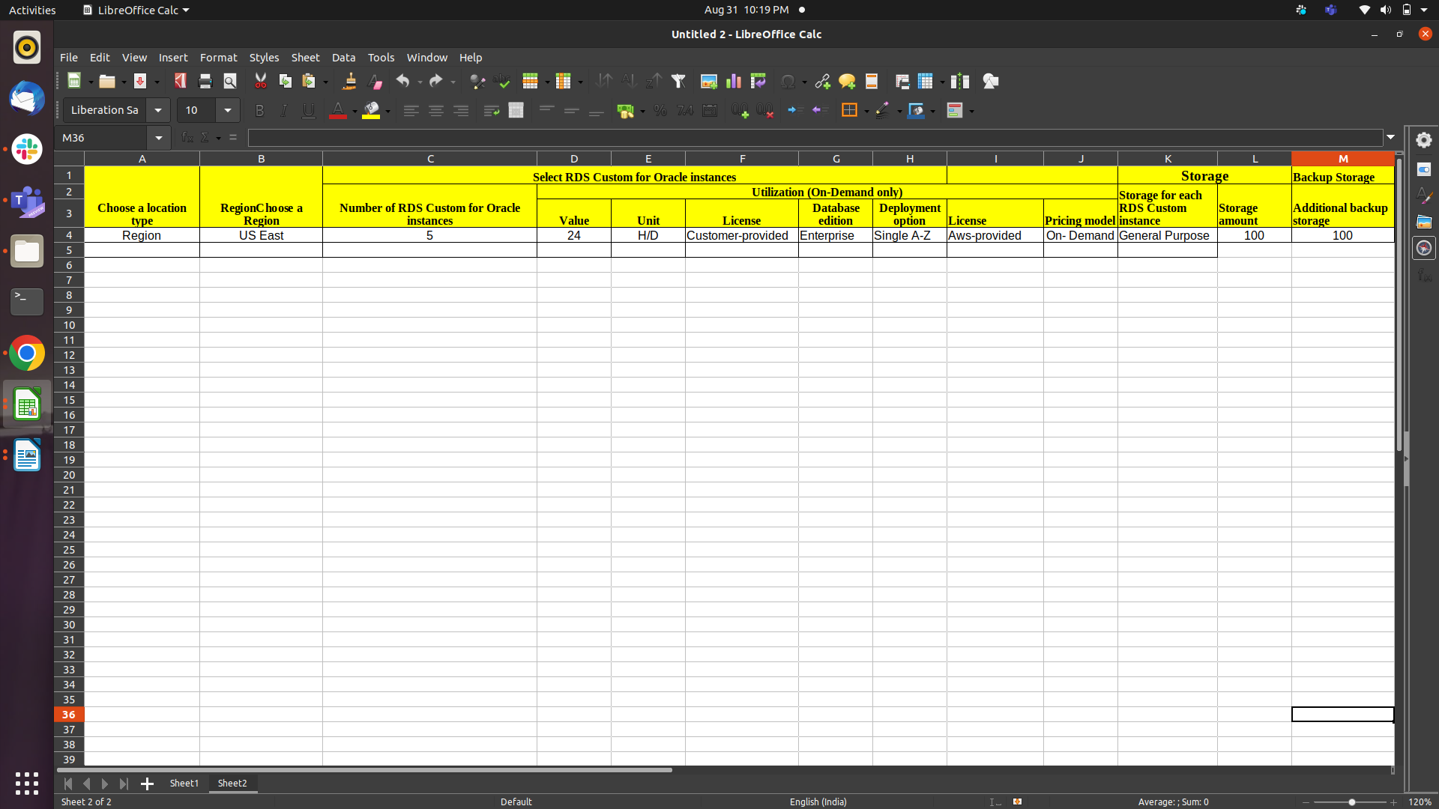
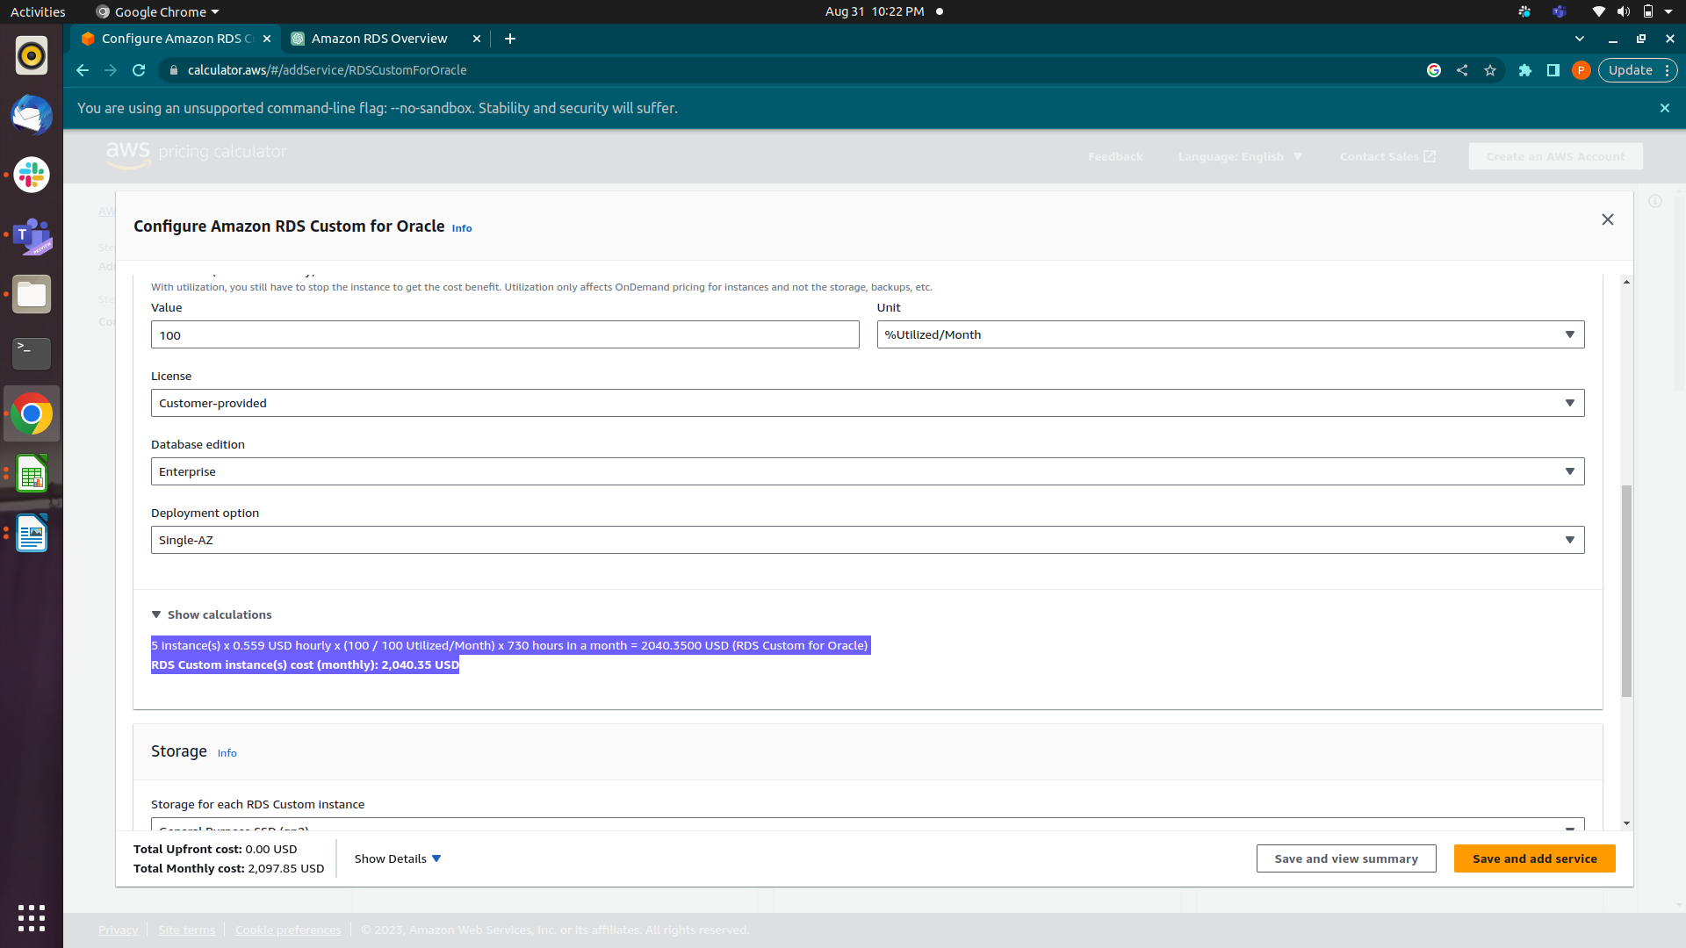
1 instance(s) x 0.559 USD hourly x (100 / 100 Utilized/Month) x 730 hours in a month = 408.0700 USD (RDS Custom for Oracle)

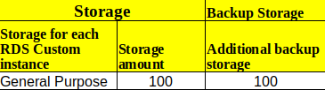
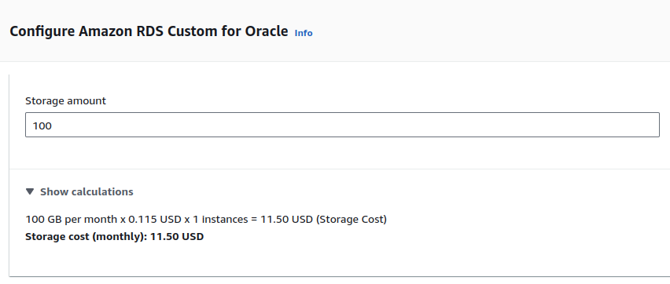
1 GB per month * 0.115 USD = 0.115 USD
100 GB per month x 0.115 USD x 1 instances = 11.50 USD (Storage Cost)
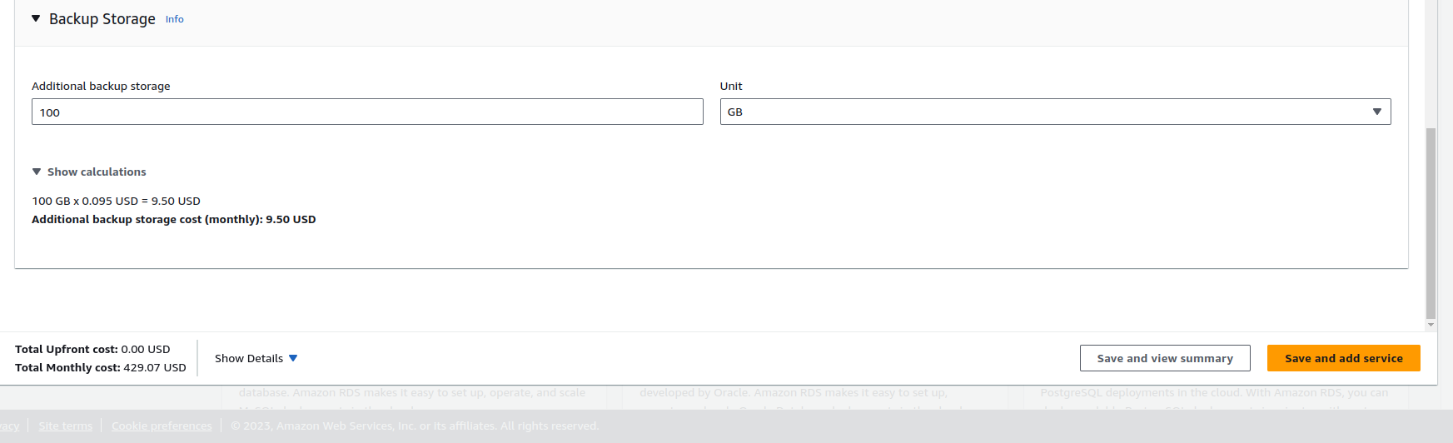
1 GB per month * 0.095 = 0.095 USD
100 GB x 0.095 USD = 9.50 USD

TOTAL PRICE
RDS Custom instance(s) cost (Monthly): 408.07 USD
Storage cost (Monthly): 11.50 USD
Additional backup storage cost (Monthly): 9.50 USD

Total Upfront cost: 0.00 USD
Total Monthly cost: 429.07 USD

2. Amazon RDS Custom for SQL Server

Amazon Relational Database Service (Amazon RDS) Custom is a managed database service for legacy, custom, and packaged applications that require access to the underlying OS and DB environment. Amazon RDS Custom automates setup, operation, and scaling of databases in the cloud while granting access to the database and underlying operating system to configure settings, install patches, and enable native features to meet the dependent application's requirements.
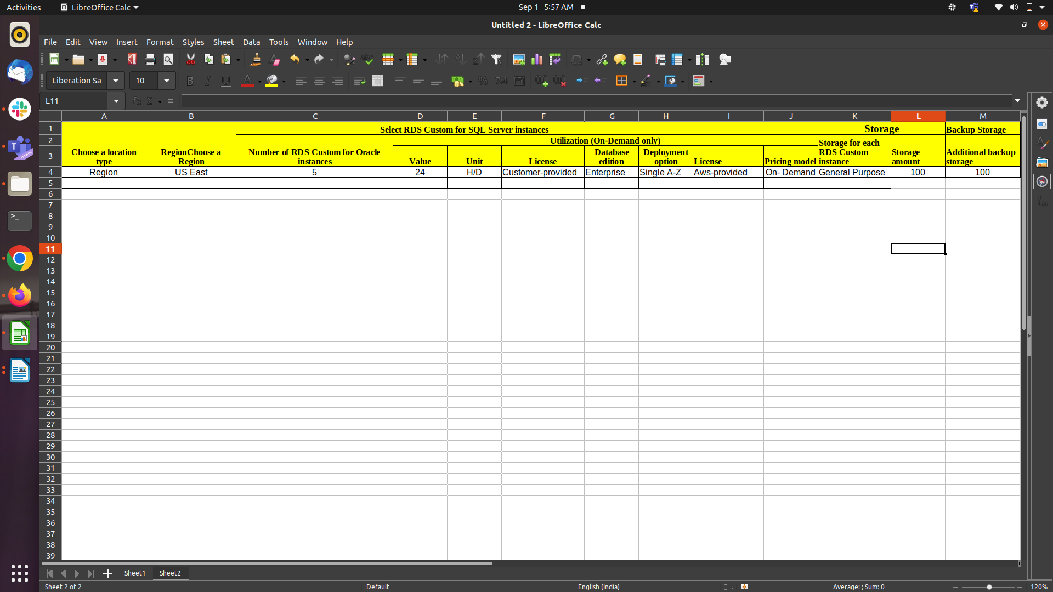
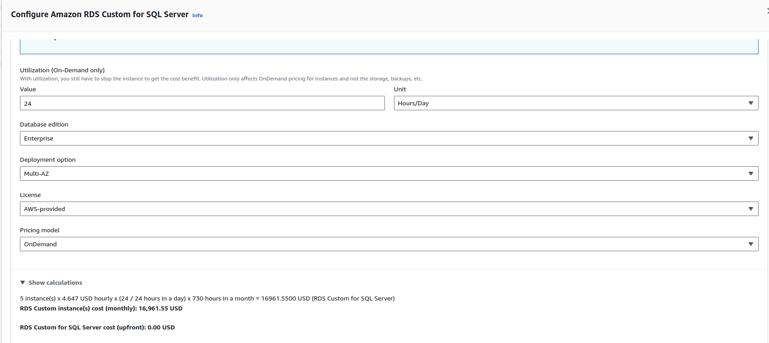
1 instance * 4.647 USD hourly *730 hours in a month =3392.31 USD
5 instance(s) x 4.647 USD hourly x (24 / 24 hours in a day) x 730 hours in a month = 16961.5500 USD (RDS Custom for SQL Server)
RDS Custom instance(s) cost (monthly): 16,961.55 USD

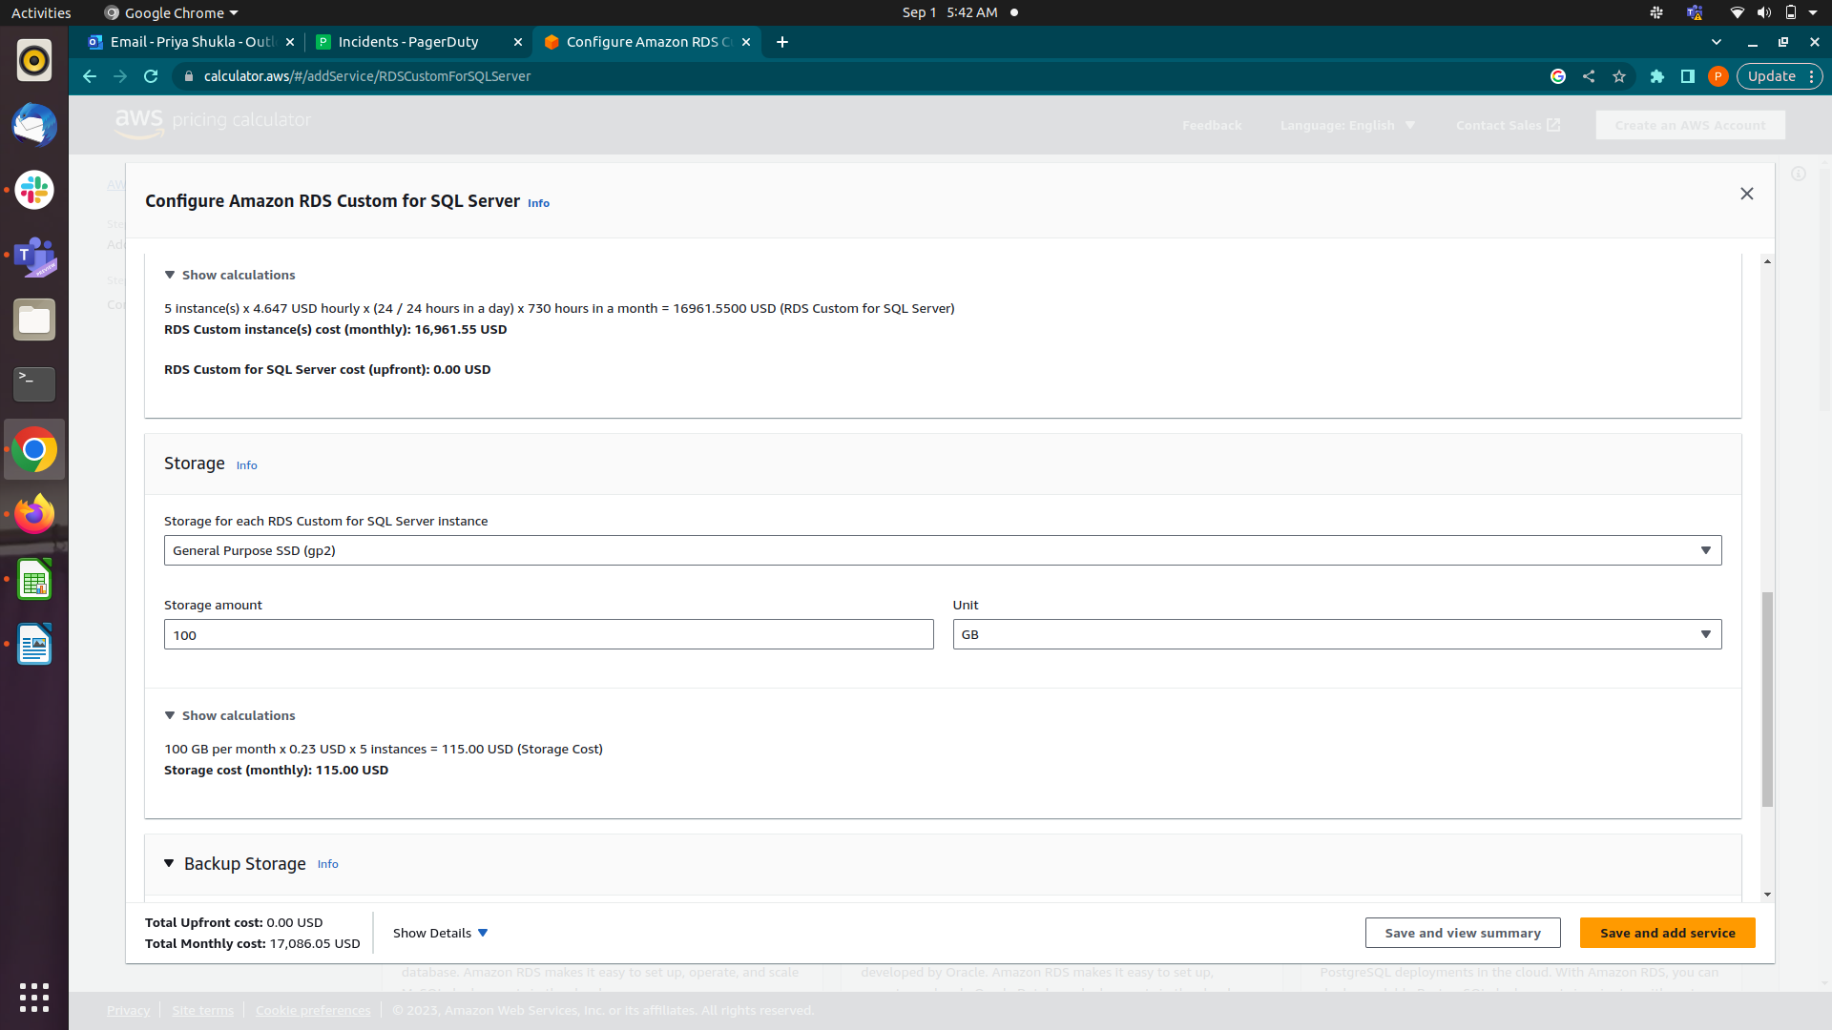
100 GB per month x 0.23 USD x 5 instances = 115.00 USD (Storage Cost)

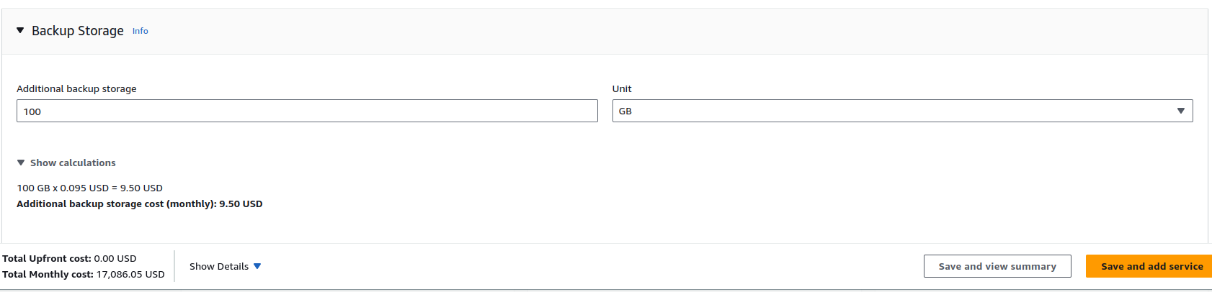
100 GB x 0.095 USD = 9.50 USD
Additional backup storage cost (monthly): 9.50 USD

Total Price
RDS Custom instance(s) cost (Monthly): 16,961.55 USD
Storage cost (Monthly): 115.00 USD
Additional backup storage cost (Monthly): 9.50 USD

3. Amazon RDS for MariaDB
Amazon RDS makes it easy to set up, operate, and scale MariaDB database deployments in the cloud.
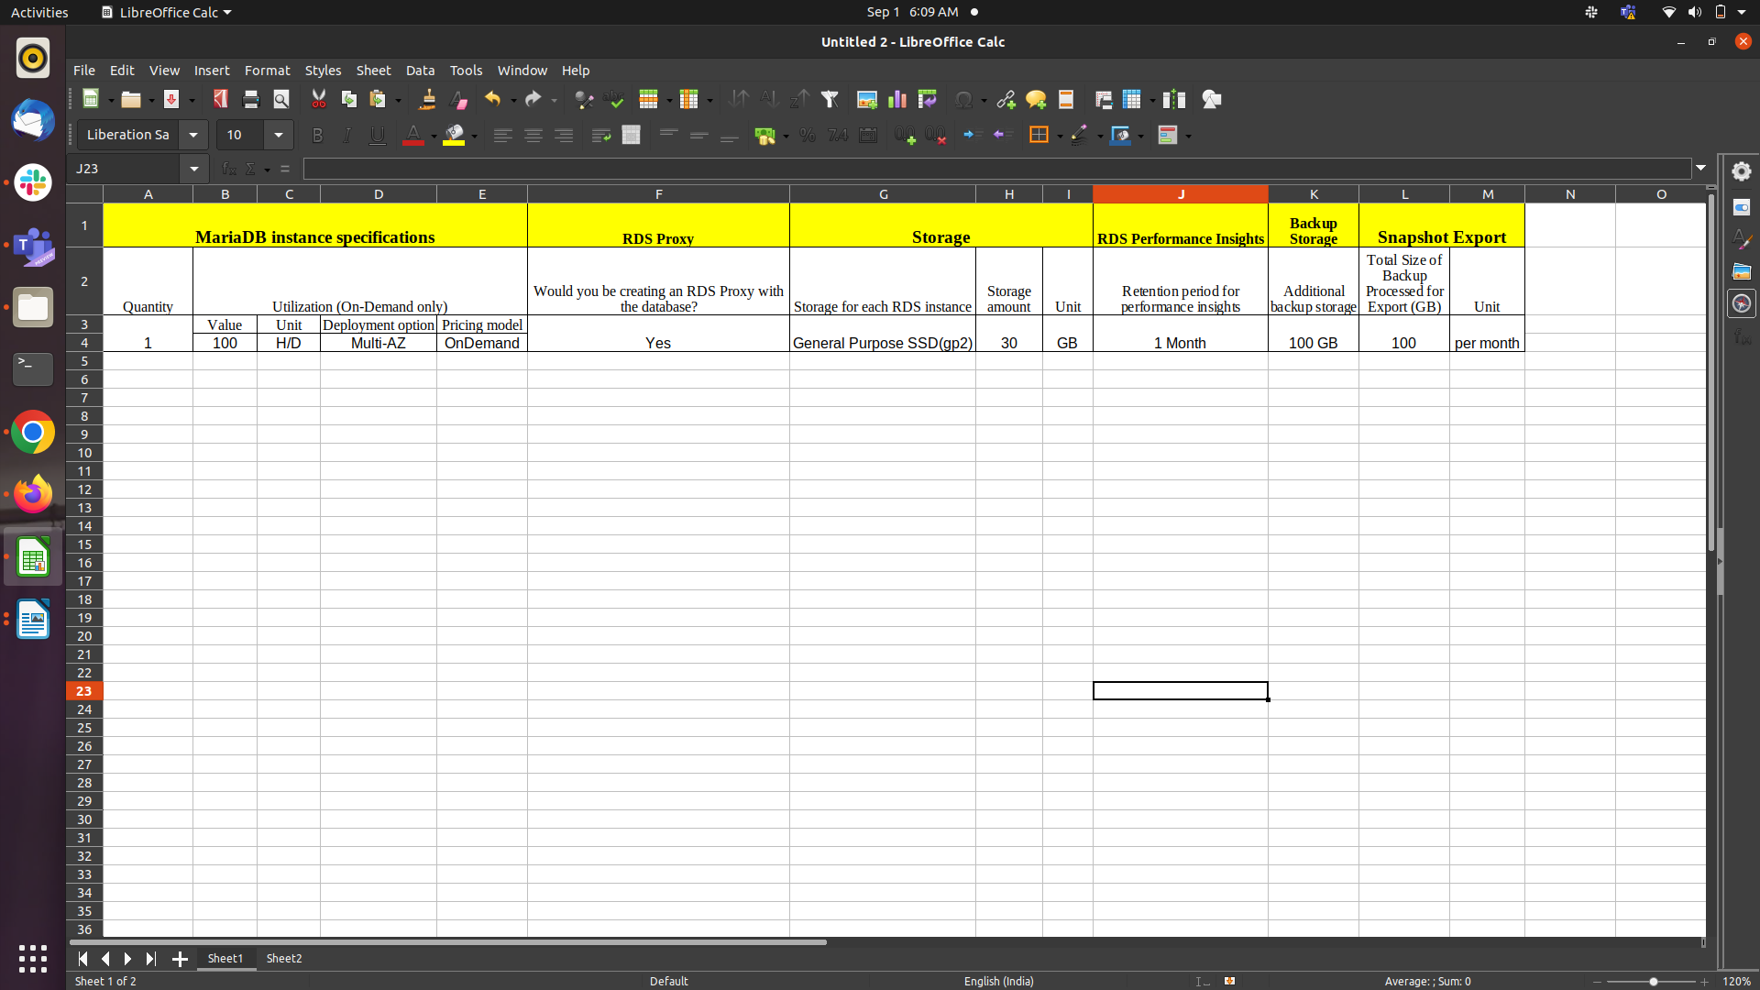
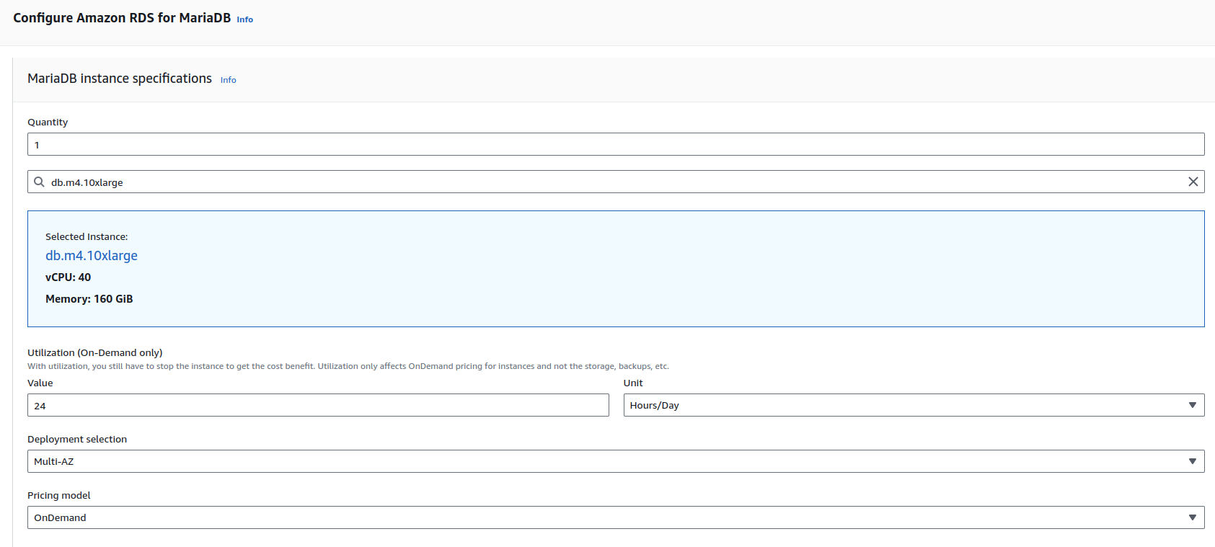

1 instance(s) x 7.004 USD hourly x (24 / 24 hours in a day) x 730 hours in a month = 5112.9200 USD
RDS MariaDB cost (monthly): 5,112.92 USD

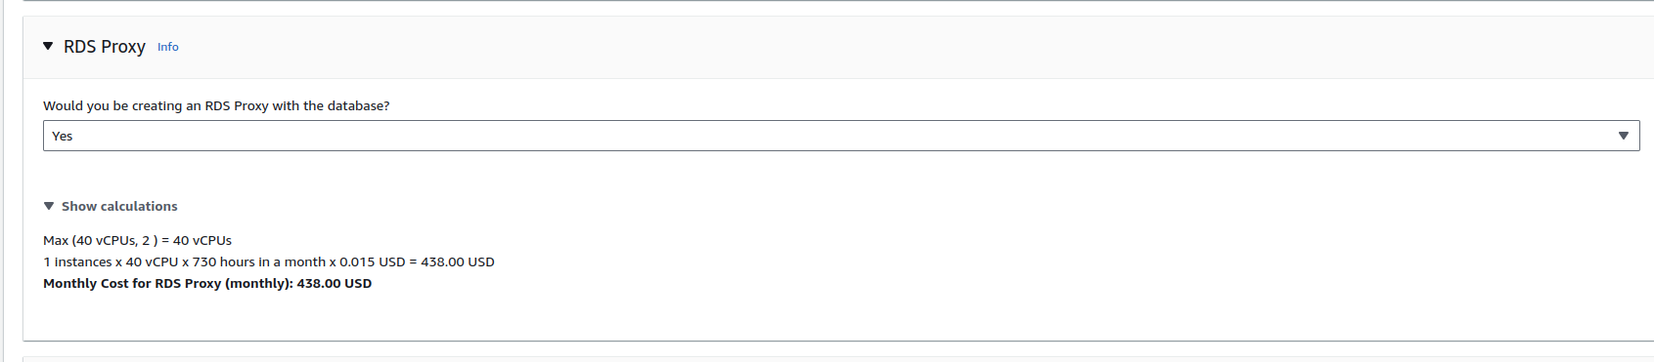

db.m4.10xlarge
vCPU: 40
Memory: 160 GiB
Max (40 vCPUs, 2 ) = 40 vCPUs
1 instances x 40 vCPU x 730 hours in a month x 0.015 USD = 438.00 USD
Monthly Cost for RDS Proxy (monthly): 438.00 USD
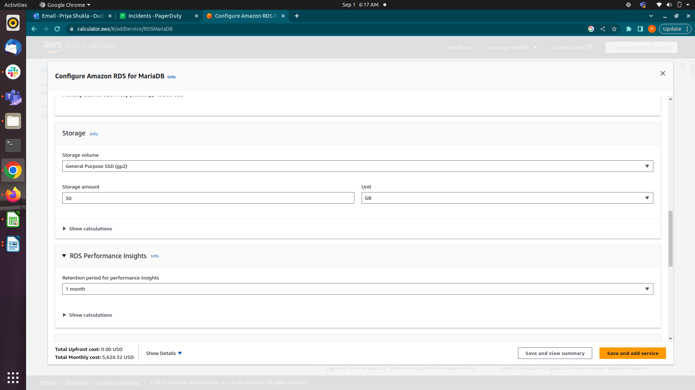
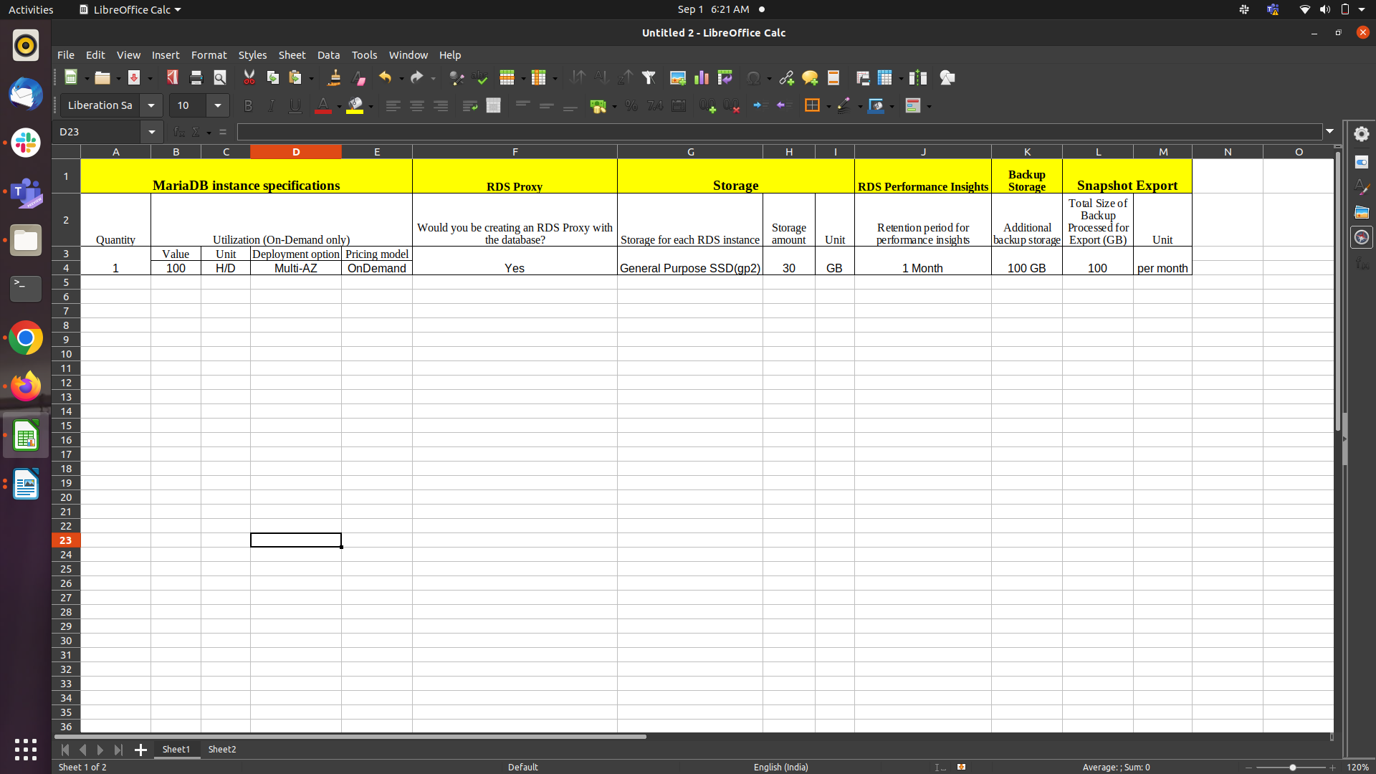

30 GB per month x 0.23 USD x 1 instances = 6.90 USD (Storage Cost)
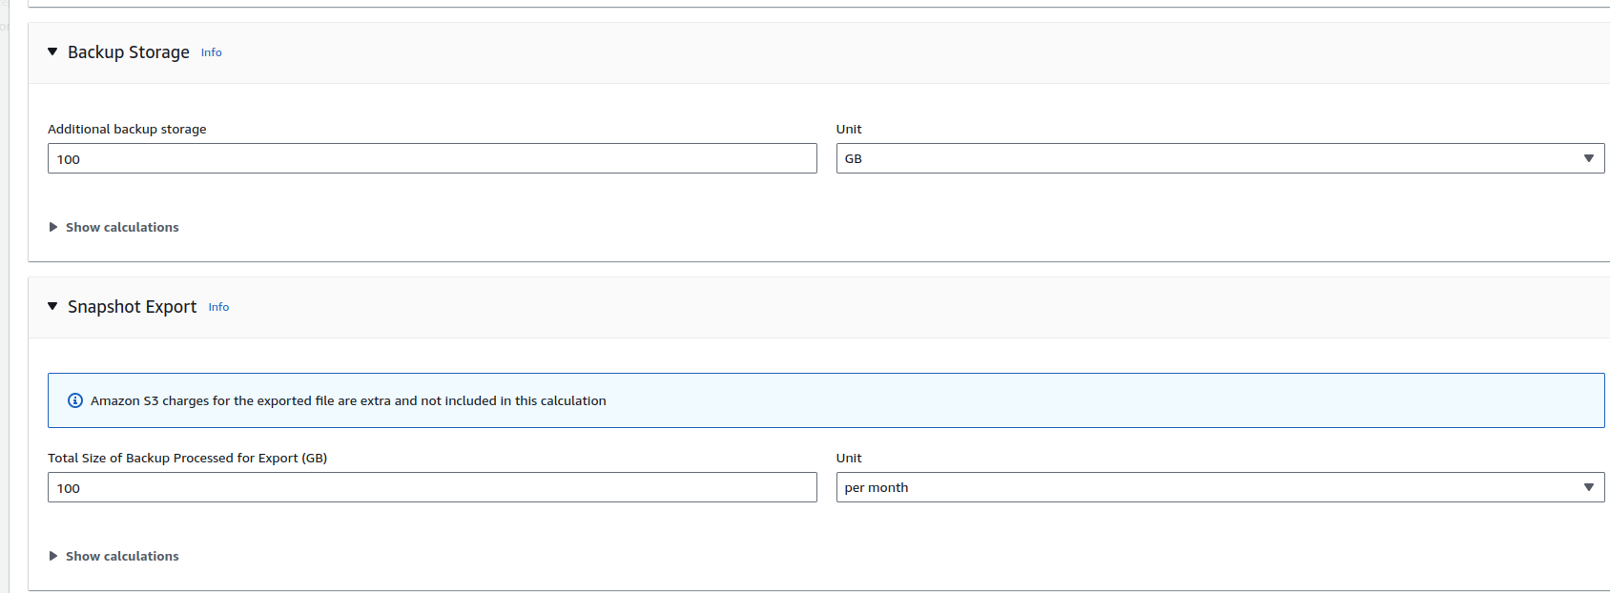
Storage pricing (monthly): 6.90 USD

100 GB x 0.095 USD = 9.50 USD
Additional backup storage cost (monthly): 9.50 USD

100 GB x 0.01 USD = 1.00 USD
Snapshot Export cost (monthly): 1.00 U

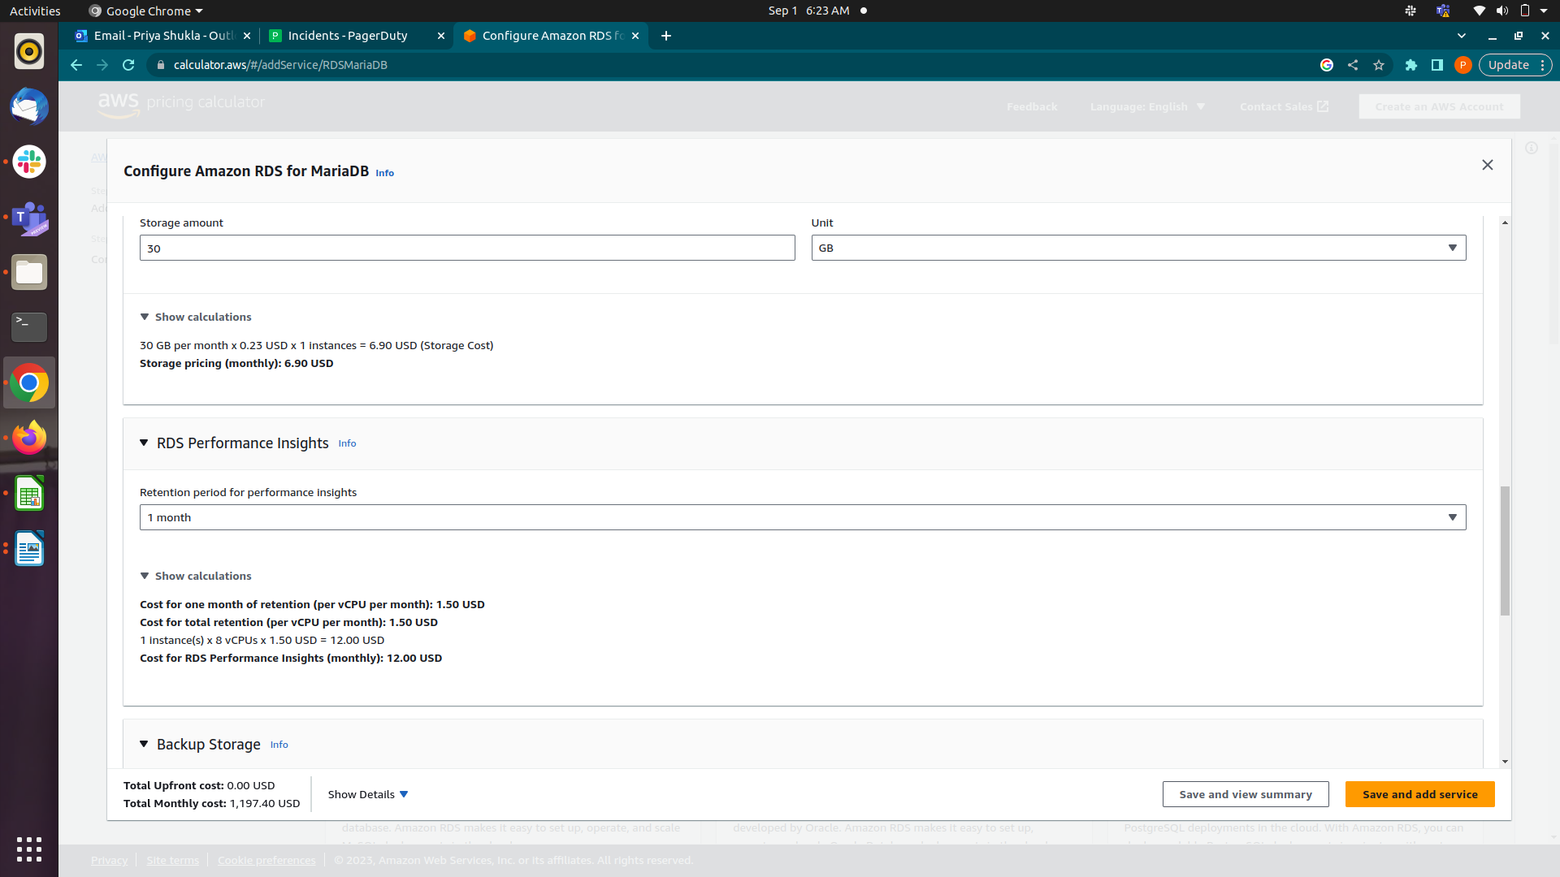
Total Price

RDS MariaDB cost (Monthly): 1,080.40 USD
Monthly Cost for RDS Proxy (Monthly): 87.60 USD
Storage pricing (Monthly):6.90 USD
Additional backup storage cost (Monthly): 9.50 USD
Snapshot Export cost (Monthly): 1.00 USD
Cost for RDS Performance Insights(Monthly): 12.00 USD

4. Amazon RDS for MySQL
MySQL is the world's most popular open source relational database. Amazon RDS makes it easy to set up, operate, and scale MySQL deployments in the cloud.

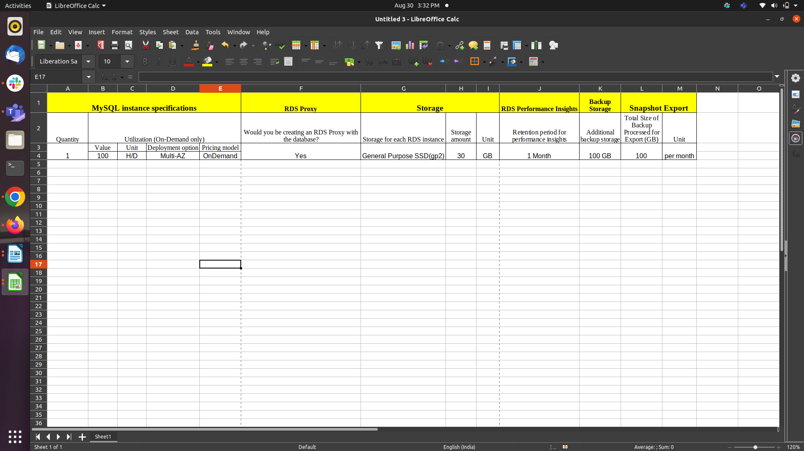

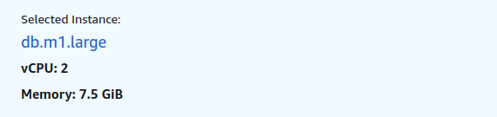
M1 General Purpose Large | db.m1.large

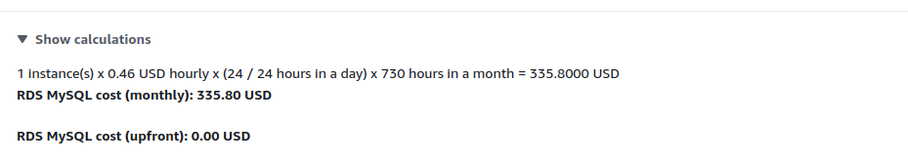
1 instance price = 0.46 USD hourly
1 month = 730 hours
0.46 * 730 = 335.8 USD

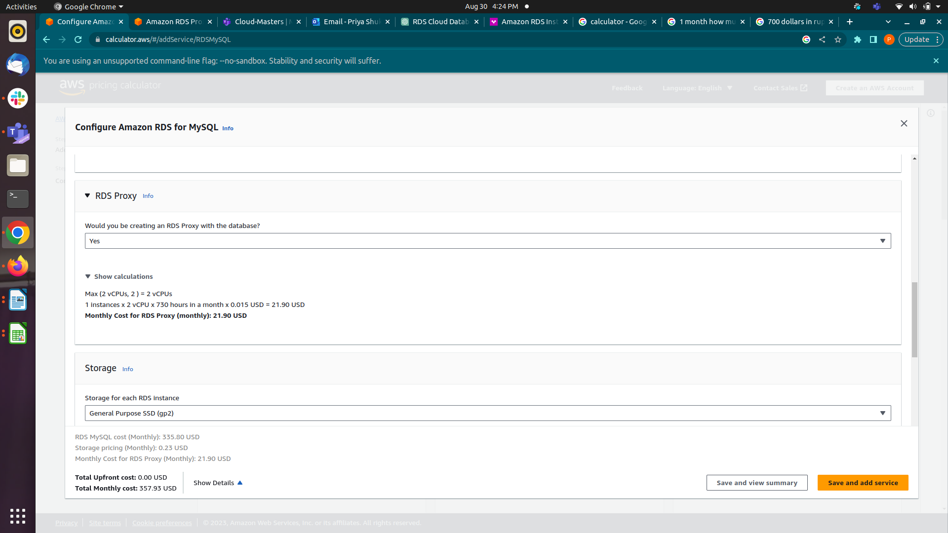
2vCPU * 730 * 0.015 = 21.9 USD

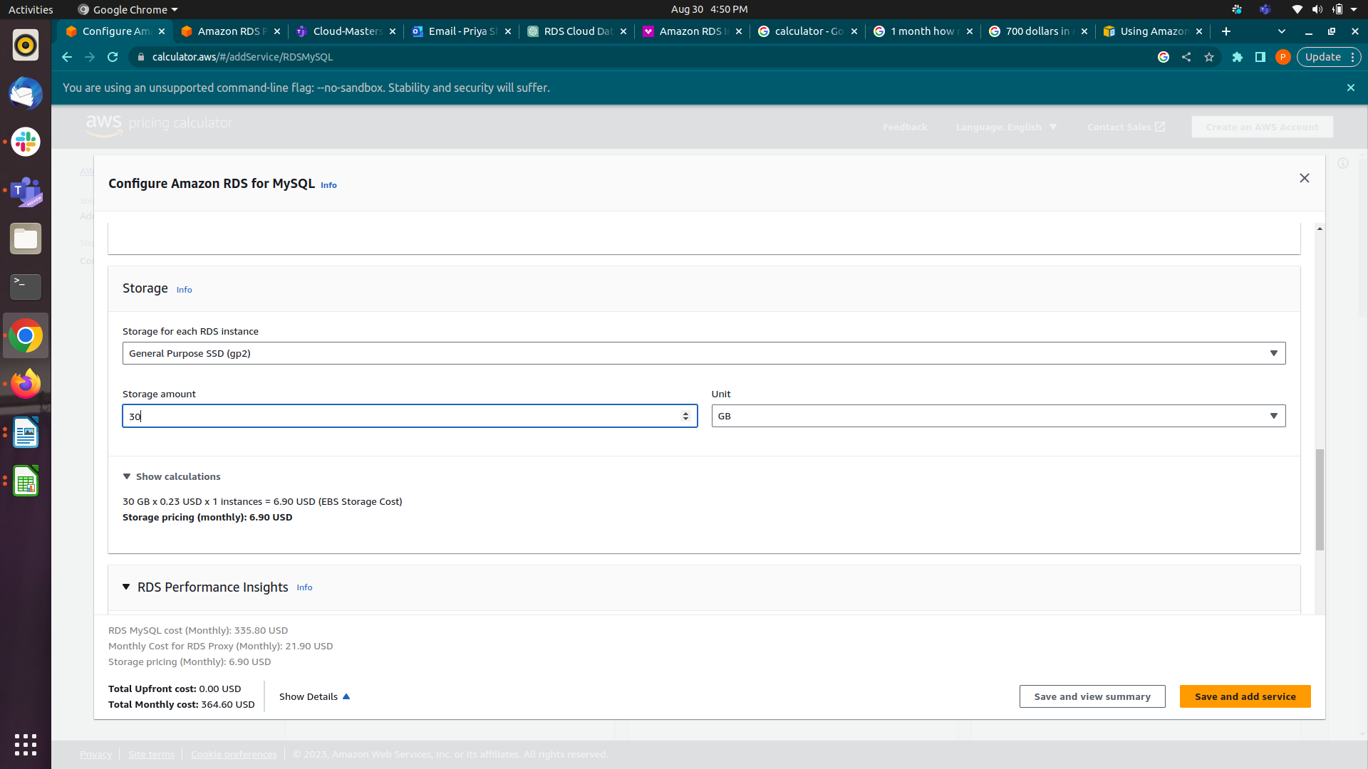

Total Price
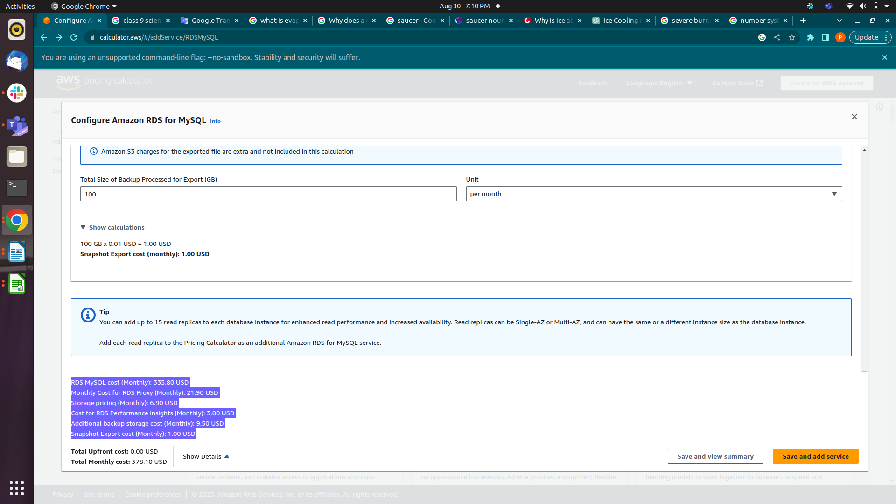

5. Amazon RDS for Oracle

Oracle® Database is a relational database management system developed by Oracle. Amazon RDS makes it easy to set up, operate, and scale Oracle Database deployments in the cloud. With Amazon RDS, you can deploy multiple editions of Oracle Database in minutes with cost-efficient and re-sizable hardware capacity.
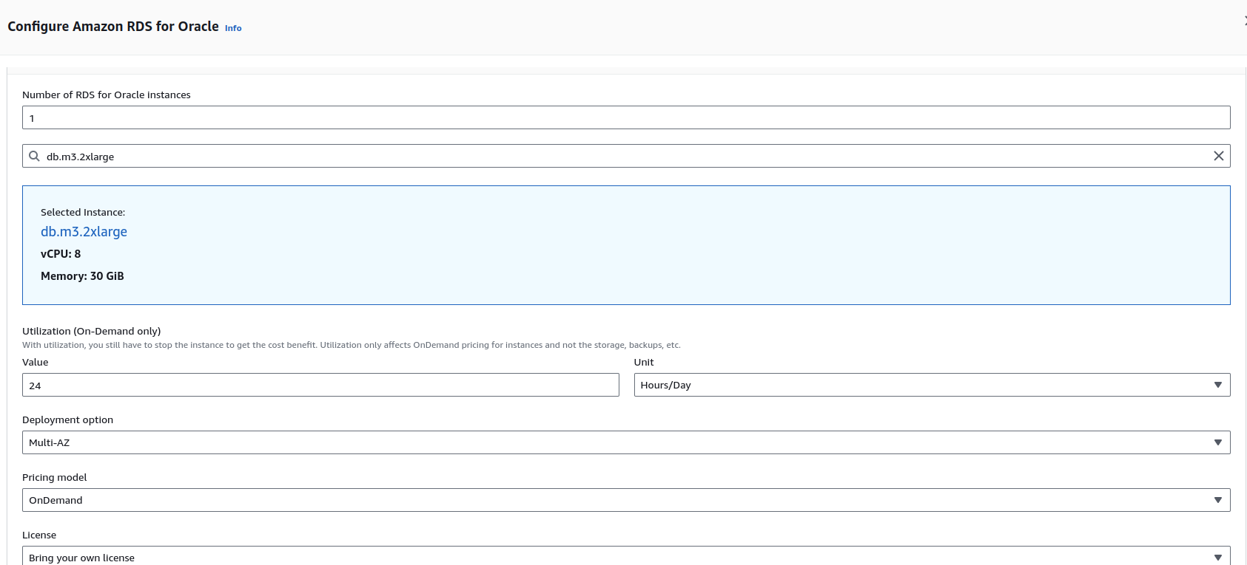
1 instance(s) x 1.48 USD hourly x (24 / 24 hours in a day) x 730 hours in a month = 1080.4000 USD (RDS for Oracle)
RDS for Oracle cost (monthly): 1,080.40 USD
RDS for Oracle cost (upfront): 0.00 USD

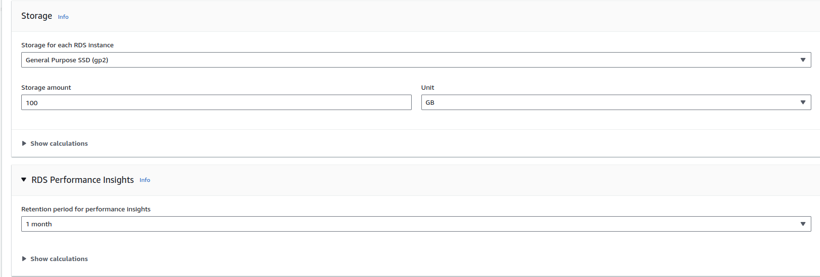
Storage calculation :

100 GB per month x 0.23 USD x 1 instances = 23.00 USD (Storage Cost)
Storage pricing (monthly): 23.00 USD

Cost for one month of retention (per vCPU per month): 1.50 USD
Cost for total retention (per vCPU per month): 1.50 USD
1 instance(s) x 8 vCPUs x 1.50 USD = 12.00 USD
Cost for RDS Performance Insights (monthly): 12.00 USD

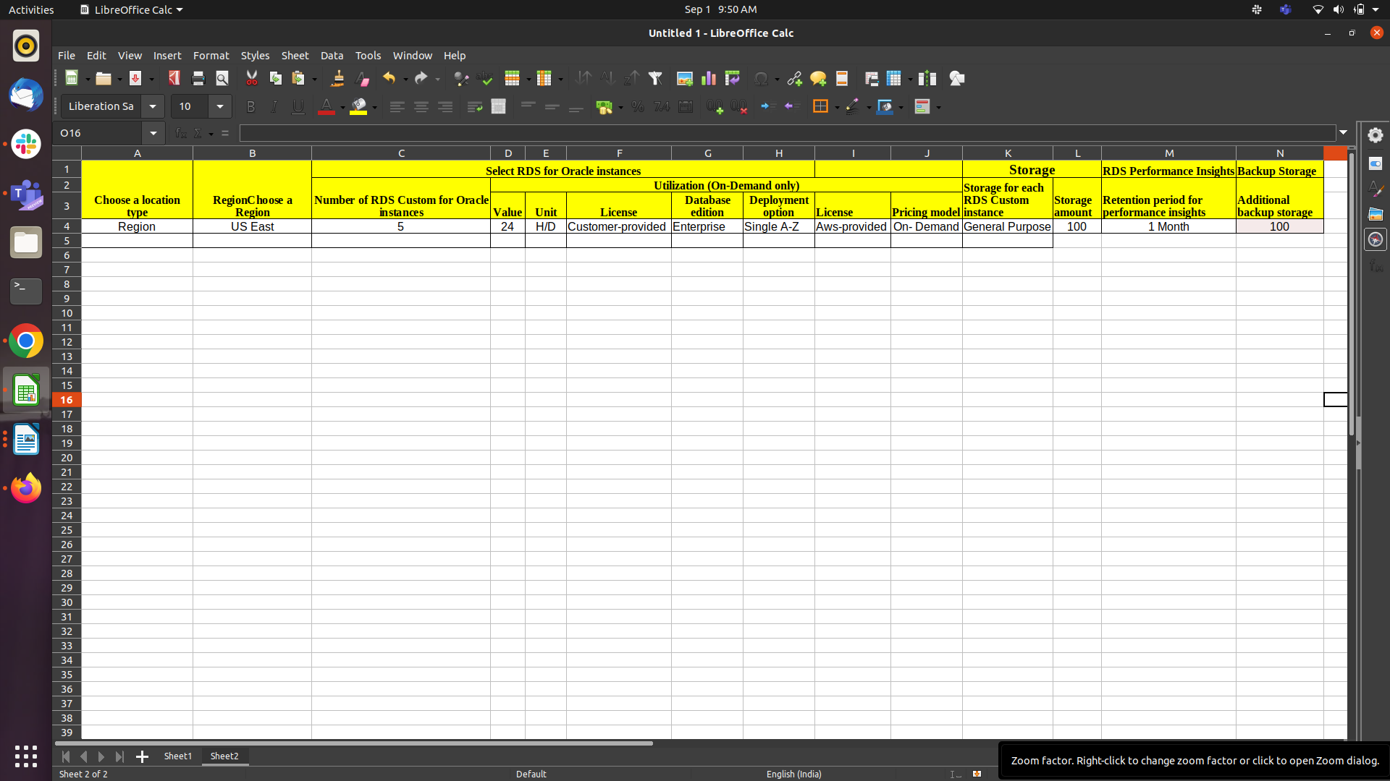

Total Price

RDS for Oracle cost (Monthly): 1,080.40 USD
Storage pricing (Monthly): 23.00 USD
Cost for RDS Performance Insights (Monthly): 12.00 USD

6. Amazon RDS for PostgreSQL

Amazon RDS makes it easy to set up, operate, and scale PostgreSQL deployments in the cloud. With Amazon RDS, you can deploy scalable PostgreSQL deployments in minutes with cost-efficient and resizable hardware capacity.

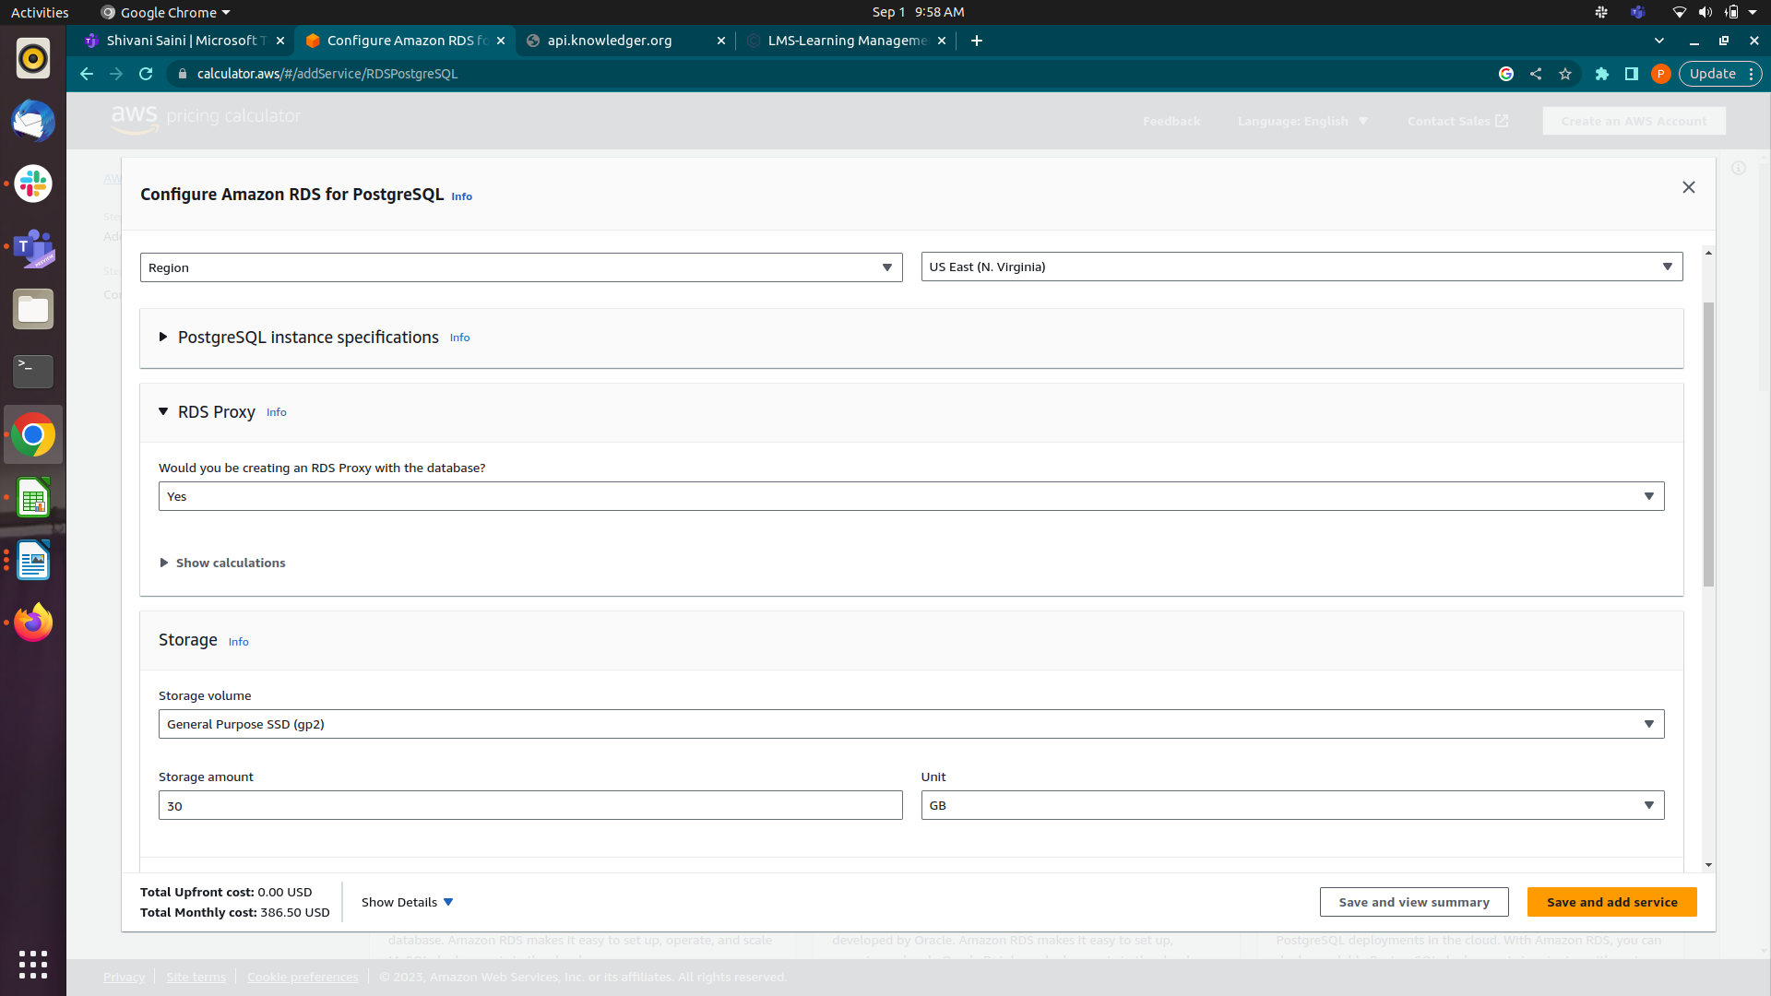
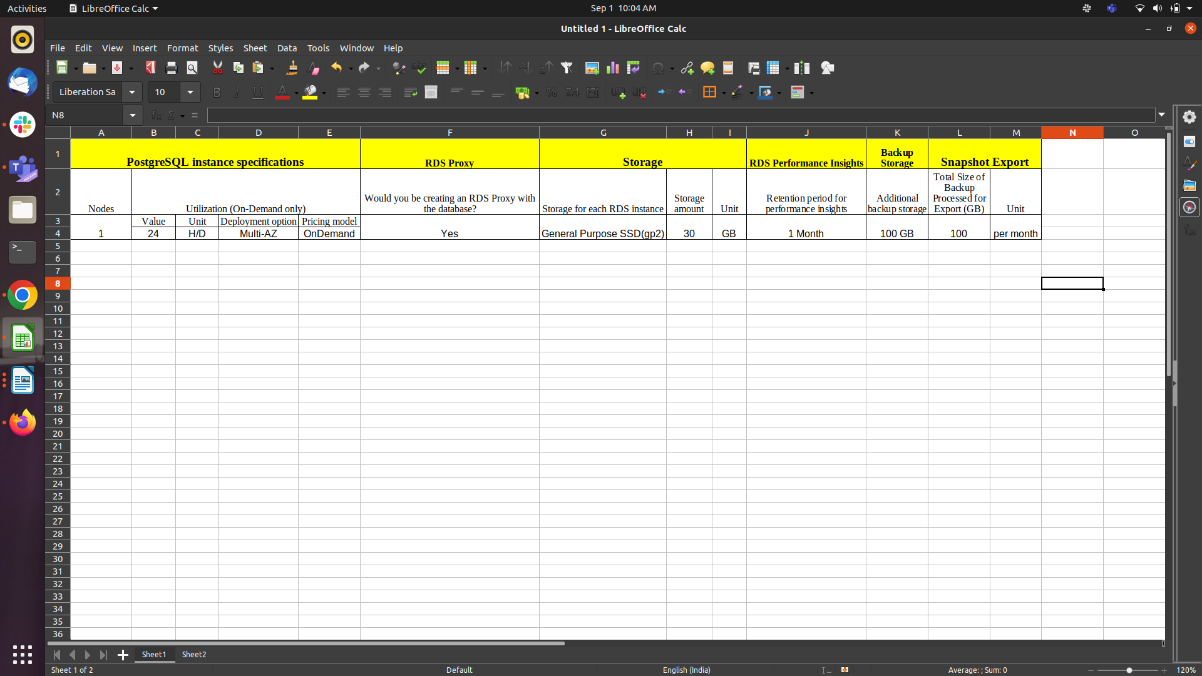
30 GB per month x 0.23 USD x 1 instances = 6.90 USD (Storage Cost)
Storage pricing (monthly): 6.90 USD

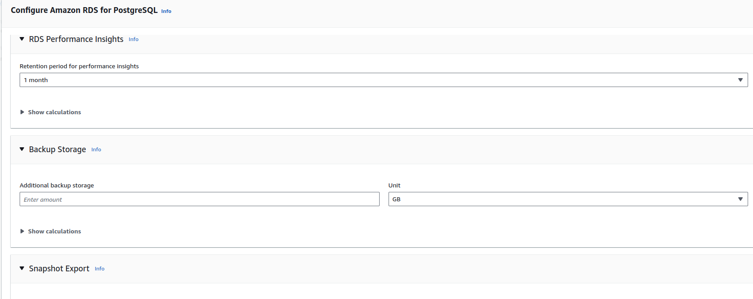

Cost for one month of retention (per vCPU per month): 1.50 USD
Cost for total retention (per vCPU per month): 1.50 USD
1 instance(s) x 2 vCPUs x 1.50 USD = 3.00 USD
Cost for RDS Performance Insights (monthly): 3.00 USD

Backup Storage
100 GB x 0.095 USD = 9.50 USD
Additional backup storage cost (monthly): 9.50 USD

Snapshot Export
100 GB x 0.01 USD = 1.00 USD
Snapshot Export cost (monthly): 1.00 USD

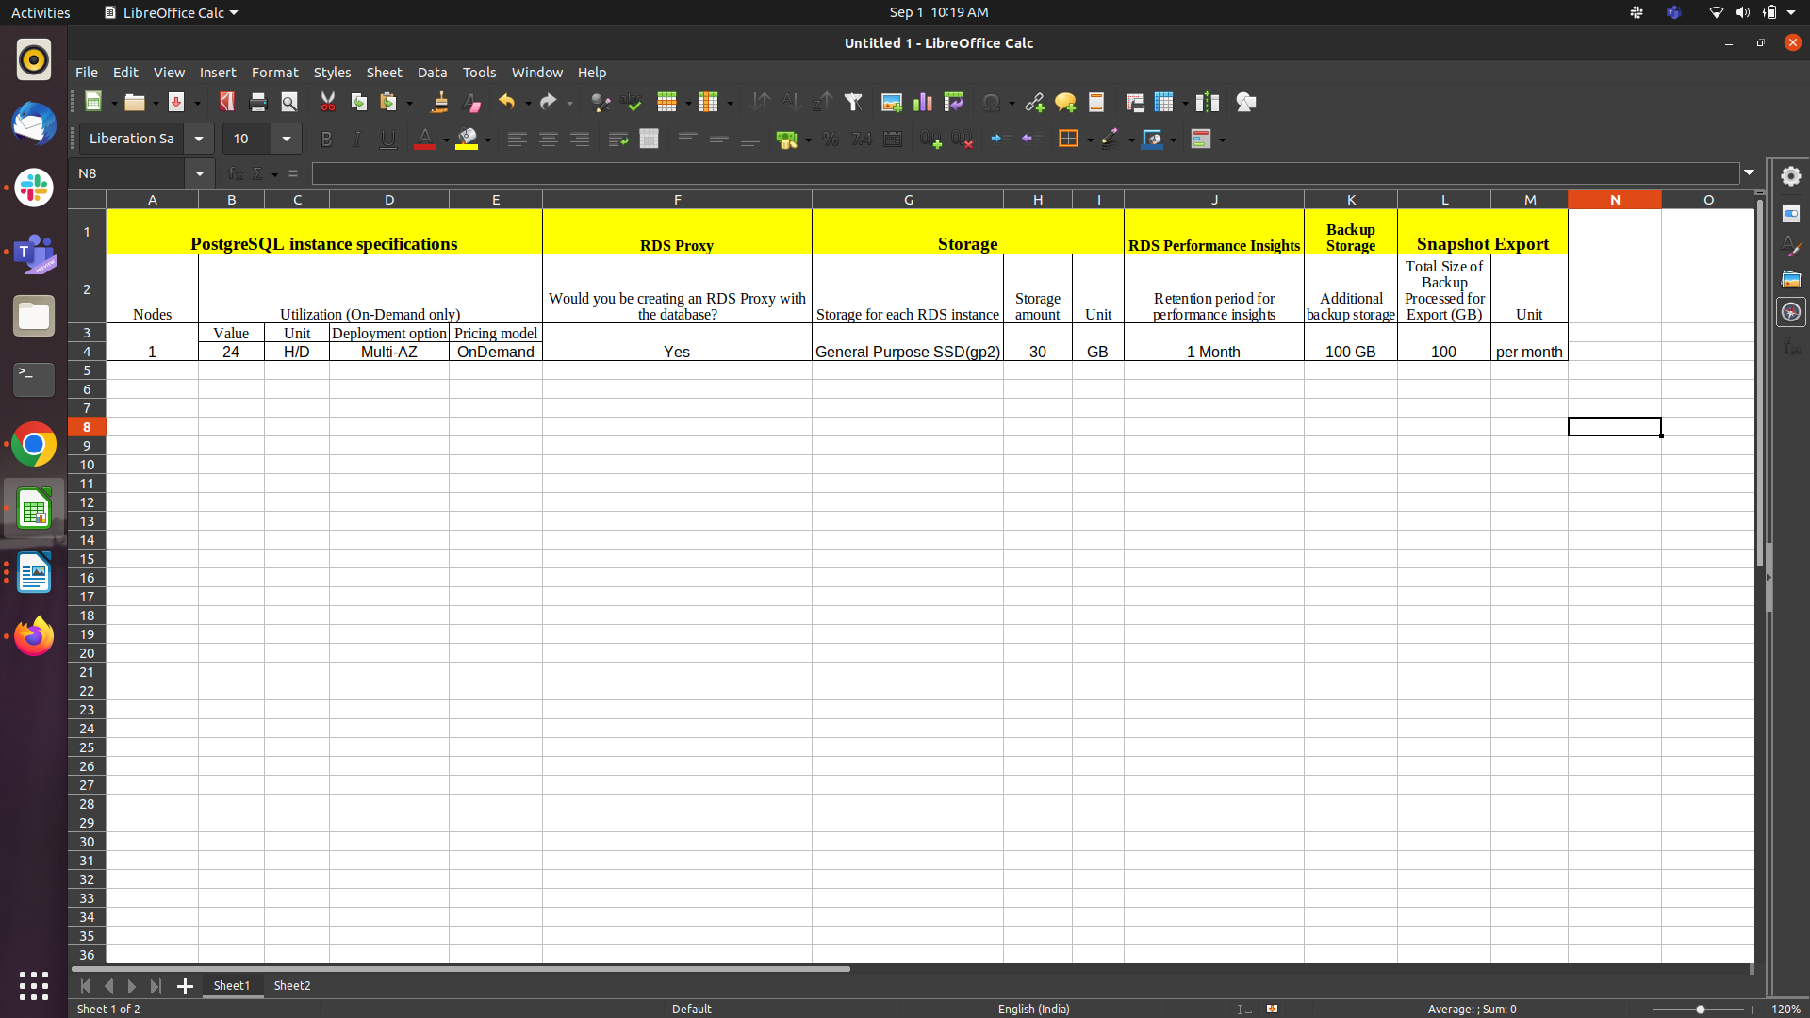
Total Price

Amazon RDS PostgreSQL instances cost (Monthly): 357.70 USD
Monthly Cost for RDS Proxy (Monthly):21.90 USD
Storage pricing (Monthly):6.90 USD
Cost for RDS Performance Insights (Monthly): 3.00 USD
Additional backup storage cost (Monthly): 9.50 USD
Snapshot Export cost (Monthly): 1.00 USD

